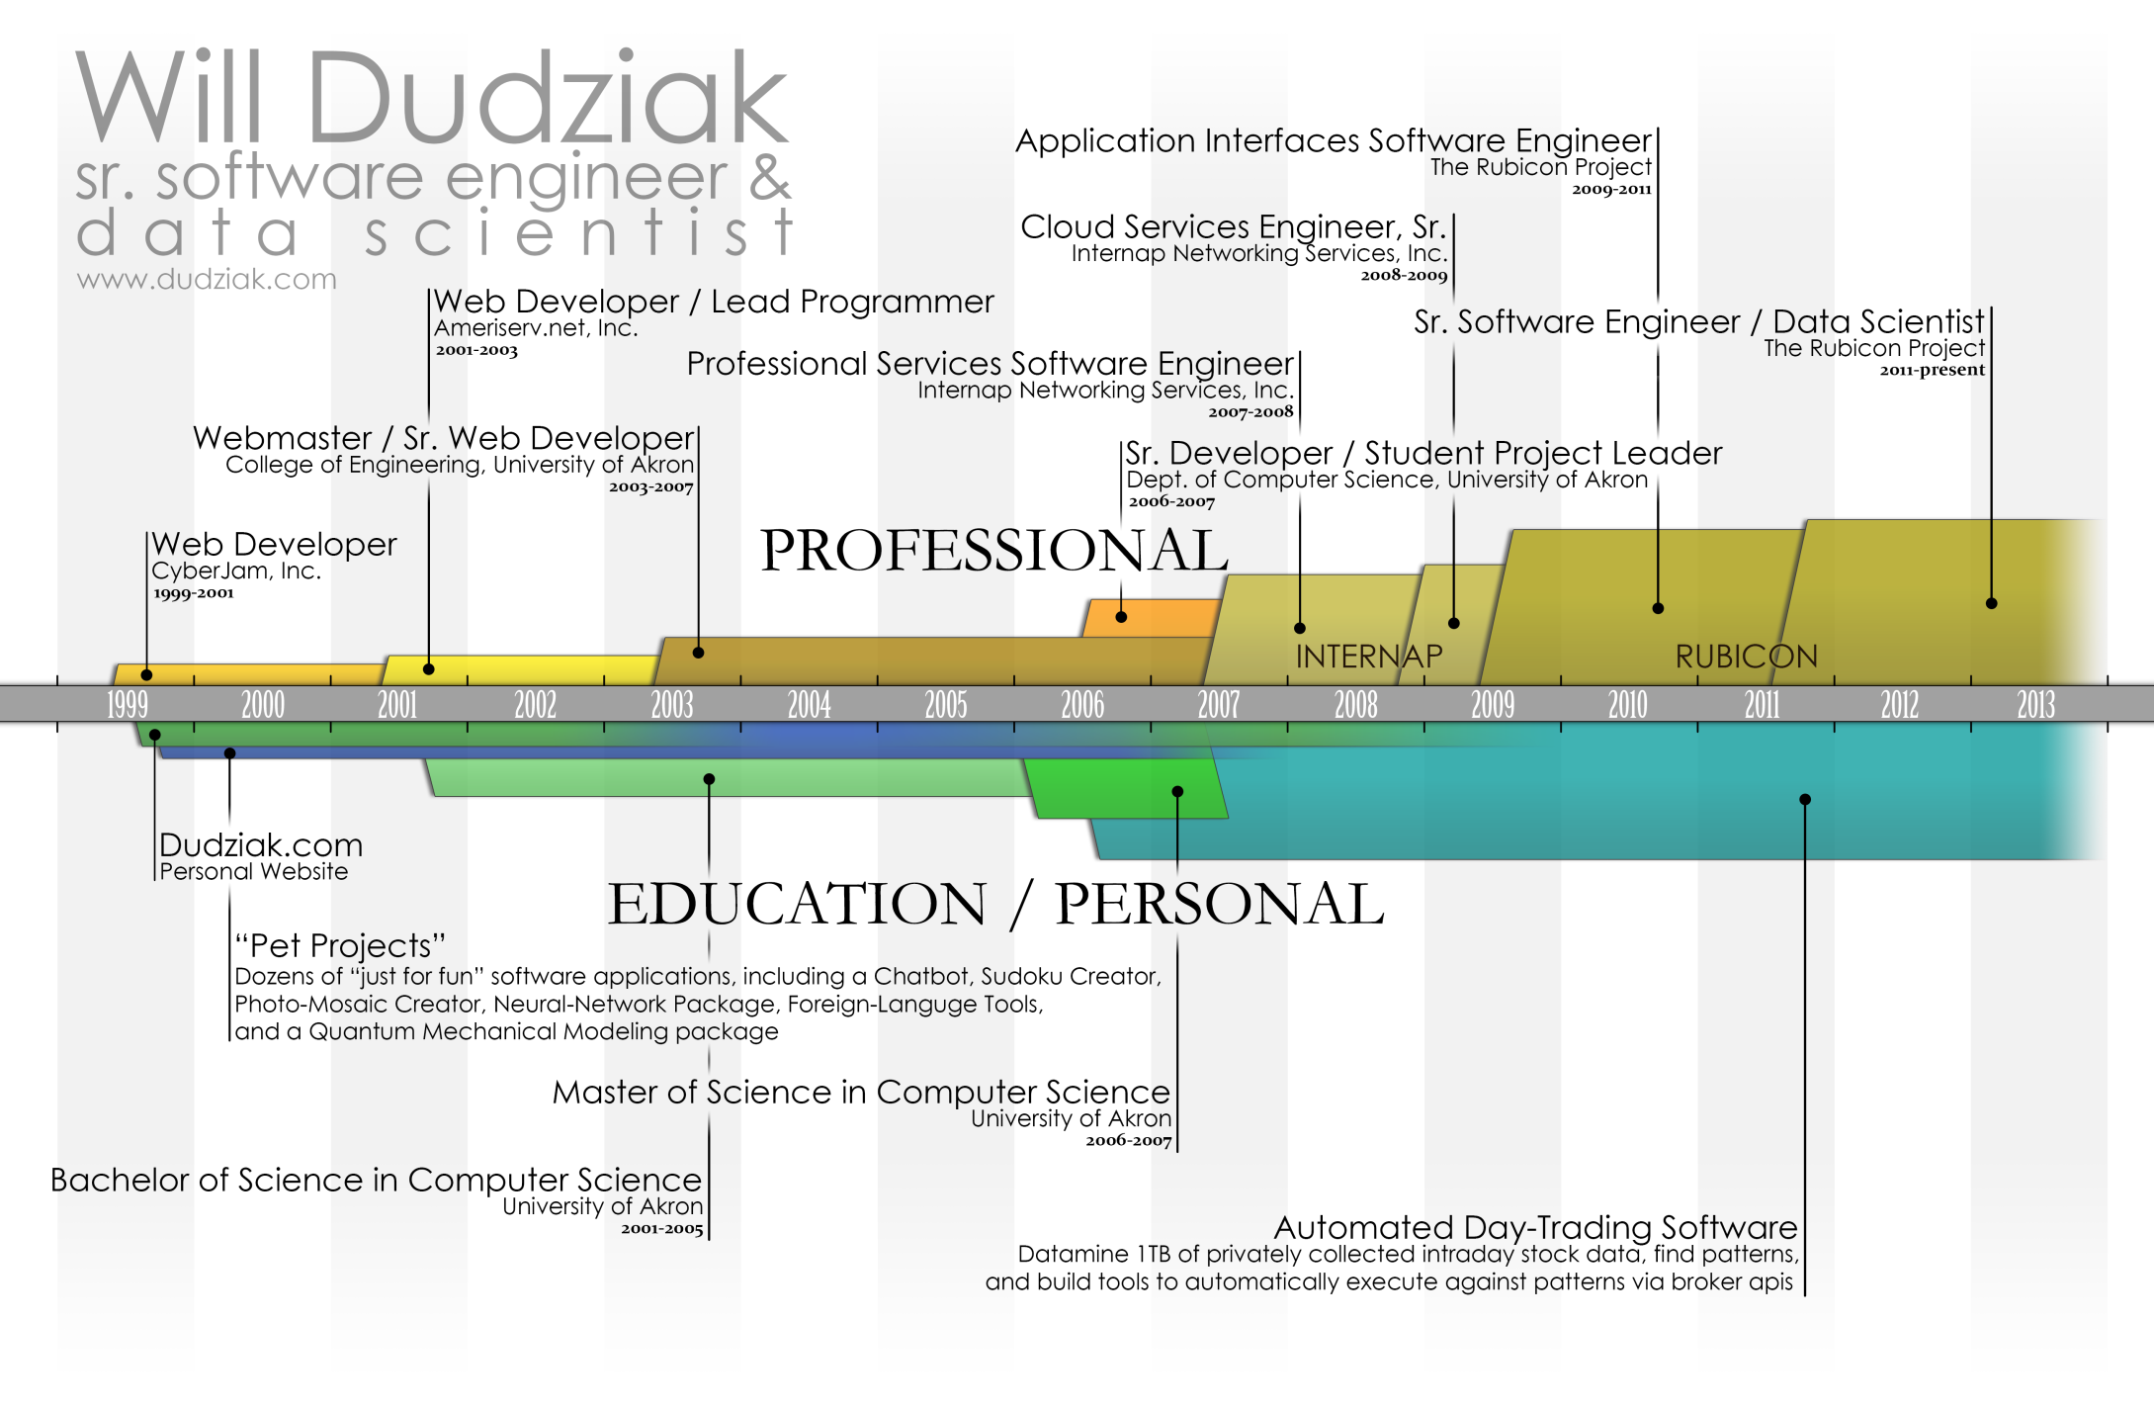
WILLIAM JAMES DUDZIAK
(330) 256-0101 (Cell)
will@dudziak.com
Personal Website: http://www.dudziak.com
LinkedIn: http://www.linkedin.com/in/willdudziak
Experience
2011–present The Rubicon Project
Sr. Software Engineer / Data Scientist
Individually responsible for core pricing systems of Rubicon's 4.5 billion online ads per day.
Create solutions to detect useful patterns in terabytes of daily logs, in order to price ads more effectively.
Provide engineering solutions for business to effectively make a variety of advertising decisions including campaign prioritization and pacing.
2009–2011 The Rubicon Project
Application Interfaces Software Engineer
Responsible for leading multi-team projects to facilitate business and engineering needs in a zero-downtime environment.
Developed and maintained "Matchmaker" service, individually targeting the 4.5 billion ads per day the company serves.
Successfully lead multi-month project to overhaul the company's financial and billing structure. New billing paradigm saved Rubicon $2.1 million/year in carrying costs.
Architected and deployed a PHP/SQL reporting engine designed to collate and report on the hundreds of billions of ads the company serves each month. Continues to function as the authoritative source of financial and business-related statistics for Rubicon and all of its clients.
2008–2009 Internap Network Services, Inc.
Cloud Services Engineer, Sr.
Created client web portal and public-facing SOAP APIs for integration with new Cloud Storage and Cloud Servers product line.
Completed fully-functioning version 1.0 of a scalable Cloud Storage solution including web-portal, credit card integration, and online file-browser in a highly demanding 3-week timeline.
2007–2008 Internap Network Services, Inc.
Professional Services Software Engineer
Developed custom content management and social networking applications for CDN clients.
Designed and implemented web 2.0 content management software suite responsible for $200,000 in direct sales and $2.3 million in related revenue.
2006–2007 Dept. of Computer Science, University of Akron / Goodyear Tire and Rubber
Senior Web Application Developer / Student Project Leader
Lead team of five graduate students on a year-long project, successfully delivering a web-based artificial intelligence software suite to Goodyear Tire and Rubber Company.
2003–2007 College of Engineering, University of Akron
Webmaster / Senior Web Developer
2001–2003 Ameriserv.net Inc.
Web Developer / Lead Programmer
Education
2001–2007 The University of Akron
Master of Science in Computer Science, 2007.
Bachelor of Science in Computer Science, 2005.
GRE perfect quantitative score of 800 (top 1% of all graduate students).
software/language experience
Software Languages  ASP.NET . . . . . . . . . . . . . . . . . . .  C# . . . . . . . . . . . . . . . . . . . . . . . .  C/C++ . . . . . . . . . . . . . . . . . . . .  CSS . . . . . . . . . . . . . . . . . . . . . . . .  CUDA . . . . . . . . . . . . . . . . . . . . .  DHTML . . . . . . . . . . . . . . . . . . .  HTML . . . . . . . . . . . . . . . . . . . . .  Java . . . . . . . . . . . . . . . . . . . . . . . .  JavaScript . . . . . . . . . . . . . . . . . . .  JavaScript w/ AJAX . . . . . . . . . .  JSON . . . . . . . . . . . . . . . . . . . . . .  LISP . . . . . . . . . . . . . . . . . . . . . . .  MS:SQL . . . . . . . . . . . . . . . . . . . .  MySQL . . . . . . . . . . . . . . . . . . . .  MySQL Stored Procedures . . . . .  PERL . . . . . . . . . . . . . . . . . . . . . .  PHP . . . . . . . . . . . . . . . . . . . . . . .  PHP 5.3 . . . . . . . . . . . . . . . . . . . .  Visual Basic .NET . . . . . . . . . . . .  XML . . . . . . . . . . . . . . . . . . . . . . .  Paradigms  Agile Development  Scrum  MVC (Model View Controller) | 1 year  7 years  3 years  6 years  1 year  5 years  14 years  1 year  13 years  5 years  5 years  1 year  1 year  5 years  2 years  2 years  10 years  3 years  3 years  3 years | Third-Party Tools  Memcached . . . . . . . . . . . . . . . . .  RPM Package Manager . . . . . . . .  Greenplum . . . . . . . . . . . . . . . . . .  Frameworks  ExtJs (Ext) . . . . . . . . . . . . . . . . . .  JQuery . . . . . . . . . . . . . . . . . . . . .  LAMP . . . . . . . . . . . . . . . . . . . . . .NET . . . . . . . . . . . . . . . . . . . . . .  Zend . . . . . . . . . . . . . . . . . . . . . . .  Artificial Intelligence Algorithms  Decision Forests . . . . . . . . . . . . .  Decision Trees . . . . . . . . . . . . . . .  Genetic Programming . . . . . . . . .  Neural Networks . . . . . . . . . . . . .  Principal Component Analysis . .  Desktop Software  Adobe Photoshop . . . . . . . . . . . .  Macromedia Dreamweaver . . . . .  Microsoft Excel . . . . . . . . . . . . . .  Microsoft IIS . . . . . . . . . . . . . . . .  Microsoft Visual Studio .Net . . . | 1 year  1 year  1 year  1 year  3 years  5 years  10 years  2 years  2 years  3 years  1 year  3 years  2 years  7 years  6 years  14 years  1 year  6 years

presentations/publications
Presentation and Analysis of a Multi-Dimensional Interpolation Function for Non-Uniform Data: Microsphere Projection. Master’s Thesis for completion of Master of Science in Computer Science. 2007. Akron, OH.
Semi-Automatic Interactive Visualization of Quantum Dot Nano-Structures. IADIS International Conference Computer Graphics and Visualization, 2007. pp. 117-121.
Multi-Dimensional Interpolation Function for Non-Uniform Data: Microsphere Projection. IADIS International Conference Computer Graphics and Visualization, 2007. pp. 143-147.
Using Fictitious Play to Find Pseudo-optimal Solutions for Full-scale Poker. International Conference on Artificial Intelligence, 2006. pp. 374-380.
Using Adaptation to Approach Nash Equilibria in Full-Scale Poker. Conference on Undergraduate and Graduate Research. November 2005. Akron, Ohio.

Recommendations (details available via LinkedIn.com or on request)
“Will is an extremely capable programmer who can communicate effectively with customers or other departments and has an eye for design as well. He can work to a schedule, design complex systems, troubleshoot problems quickly, and leverage his insights to fill in gaps within specs to deliver what the customer really needs.”
Jason Eggleston, Team Lead, Solutions Engineer – Manager
“I have worked very closely with Will at the Rubicon Project. As the engineering lead on the Bid Landscape Report, Will showed excellent skill in understanding the nuances of design, programming and scale during the concept phase. He understood the customer and their needs which guided his design contributions. The report he produced became a cornerstone of Rubicon's Real-Time Bidding product.
Will thinks on his feet and can plug into a variety of concepts quickly. His dogged nature makes him an extremely reliable asset. I would trust Will to lead any project, no matter how complex or difficult.”
Mark McEachran, Product Manager – Coworker
“Will joined our team as a new developer to extend our delivery capacity in Professional Services. Within his first week he was already up to speed in his new role and was making significant contributions to the team. Will has excellent technical and documentation skills, as well as customer skills and within a few weeks he assumed the primary lead role for a critical business project which he completed it on time and with excellent results. Will is an outstanding individual with great future potential that I would highly recommend for any position where his skills are needed.”
Jay LaCroix, Global Manager, Strategic Partner Alliances – Manager
“Will is an analytical thinker who enjoys solving difficult problems. And, he does this very well. His solutions are always of top-notch quality and elegant. Will is also a pleasure to work with as his easy-going style makes working together on difficult issues a breeze.”
Bill Willits, Sr. Database Administrator – Coworker
“I worked closely with Will for about a year at the Rubicon Project. Will is an excellent software engineer, highly analytical and able to reason about and break down complex problems. He has the ability to work effectively anywhere in the stack, as evidenced by his work on both big data and user interfaces at Rubicon. He has a great work ethic, works well with others and communicates clearly.
I am sure he would be of great help to any organization that needs real software engineering skills, and I'd be happy to work with him again.”
Will Redd, Core Software Engineer – Coworker
“Will was a tremendous asset to the company. He has the rare ability to assist both behind the scenes and in front of the customer. He has a tremendous knowledge base that he shares in an easy to understand yet informative matter. I've worked with Will on specific customer applications where he was both instrumental in implementation and more importantly a vital component to closing the deal.”
Jeff Bettencourt, CDN - Sales Engineer – Coworker
“I had the benefit of working closely with Will for nearly two years on the Interfaces team at the Rubicon Project. During that time, Will was responsible for leading several critical engineering projects ranging from an multi-layered user authorization interface to a complete redesign of the company’s financial tracking system. On each project, Will was extremely effective in gathering the necessary requirements, drafting an elegant technical design, and successfully implementing a solution that met all project requirements.
Will is not only an avid problem solver who craves learning and stretching himself to tackle new challenges, he is also a willing teacher often encouraging others to stretch themselves as well. I thoroughly enjoyed working with Will, and recommend him with my highest regard.”
Brad Rodriguez, Software Engineer – Coworker
More recommendations are available
via LinkedIn profile: http://www.linkedin.com/in/willdudziak
or via personal website: http://www.dudziak.com/resume.php
References
Please do not contact these individuals without first consulting me.
Name: Jason Eggleston
Mutual Employer: Internap Network Services, Inc.
Title: Team Lead, Solutions Engineer
Relationship: Supervisor
Phone: (949) 351 4096 (cell)
Email: jason@eggnet.com
Name: Brad Rodriguez
Mutual Employer: The Rubicon Project
Title: Team Lead, Interfaces Engineer
Relationship: Coworker
Phone: (626) 780 1041 (cell)
Email: brad@brodrigu.net
Name: Mike Kowalski
Mutual Employer: Internap Network Services, Inc.
Title: Sales Engineer
Relationship: Coworker
Phone: (949) 355 3710 (cell)
Email: mkski@yahoo.com
Name: Dr. Chien-Chung Chan
Mutual Employer: Department of Computer Science, University of Akron
Title: Professor of Computer Science
Relationship: Supervisory Faculty Member/ Department Chair
Phone: (330) 972 8014 (land line)
Email: chan@cs.uakron.edu
Additional references can be provided upon request.

